Contents

Contents 1
Overview 2
Linking the DLL (Win95, WinNT/2000). 2
Create Signature 3
Signature Properties 3
Defining Operations 5
Defining Parameters: 6
Compile the Signature. 7
Uniface code 7

Overview

As with all things Uniface, they are simple once you have done it once. Working out how to do it and knowing whether you have done all that is required is the hard part. This document details the requirements for implementing a call to a Windows API DLL.

There are 4 steps:
- Tell Uniface about the DLL
- Define the DLL’s operations and parameters in the signature file
- Compile the signature.
- Implement the code to call the operation.

There are no other requirements. If all is done correctly, it will just work, despite the fact that you are using a function from Kernel32.DLL (for example) and you haven’t told the signature where the DLL lives, or even which DLL the operation is in. Trust the magic of Uniface…. ☺

----------------------------------------------------

Linking the DLL (Win95, WinNT/2000).

Uniface has to be able to find the DLL, so it’s location needs to be initialised
- Modify the usys.ini file for your application, so the [userdlls] section has a path entry under which the full path (excluding filename) of the DLL. If there are multiple DLLs to be defined, then it is necessary to have them all in the same folder, since you can only specify one path statement in the [userdlls] section.

And also has to be told that the DLL should be preloaded and made ready
- Modify the usys.ini file for your application, ensure that the [userdlls] section has a demandload entry and the DLL name is among those listed. Add the DLL (and the demandload entry) if not present, separating each DLL name with a comma.

Example

[userdlls]
PATH=C:\WINNT\SYSTEM32 ;WinNT/2000
demandload=ADVAPI32.DLL

----------------------------------------

Note: Any external DLLs have to be shipped and installed to implement the application.

Create Signature

Signature Properties
The Define Signatures form can be found many ways.

- Select Editors/Signatures to load the Define Signatures form.
- From the Assembly group, click on the Signatures image.
- Et al...

Both of these take you to the “Open Component Signature” window, which prompts for the name of an existing Signature....
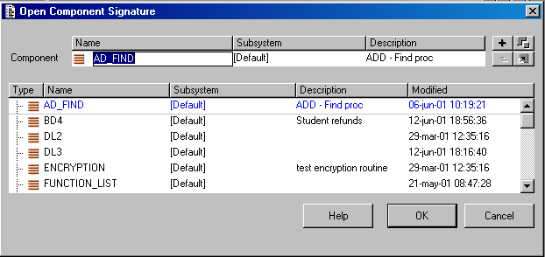From her you can select an existing signature (if you simply want to add an operation), or create a new signature.

Either way, the next window is the Define Signature window.

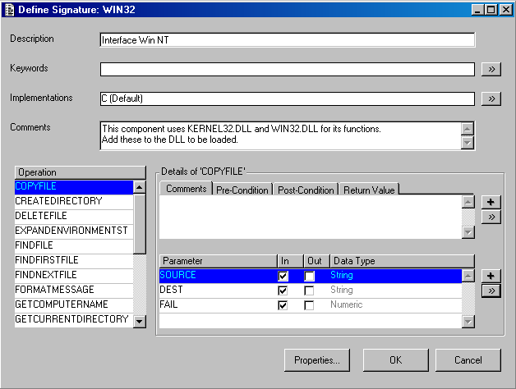

Enter a Description, and any comments as required.

Implementation: C (no need to specify any of the properties of the C implementation type)

Note:
- There are two sets of +, >> controls, the upper one is for adding and setting the properties of operations, the lower one for the parameters of the operations

- There are many implementation types. Windows API DLLs use C. Other DLLs and external components may use other implementation types, this document only discusses the C implementation type.

Defining Operations
Click the upper >> button to enter operations and set the operation properties.

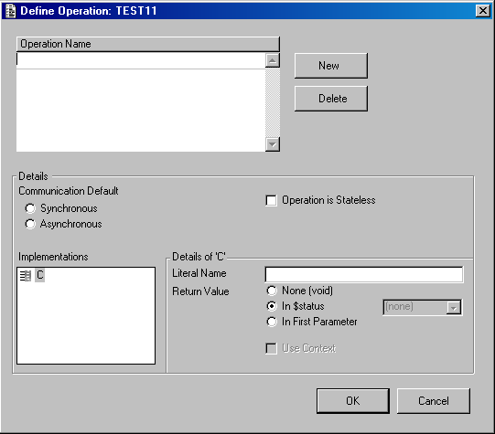

Generally, accepting the default values for everything, except the literal name, will be all that is required. The default Literal Name however will most likely be set to <SignatureName>_<OperationName> change this to be the appropriate DLL entry point name....

Example:

Operation: getusername

Default Literal Name: win32_getusername (where win32 is the chosen name of the signature).
Correct Literal Name: GetUserNameA

Set the Return value to match the return type of the DLL

Note: if the literal name, or the number and type of parameters does not match the DLL definition, all that will occur is a return statement to the effect that Uniface could not find the specified operation.

Defining Parameters:
Most DLL operations take parameters. These will need to be configured. Click the lower >> button to enter the parameters for the selected operation.

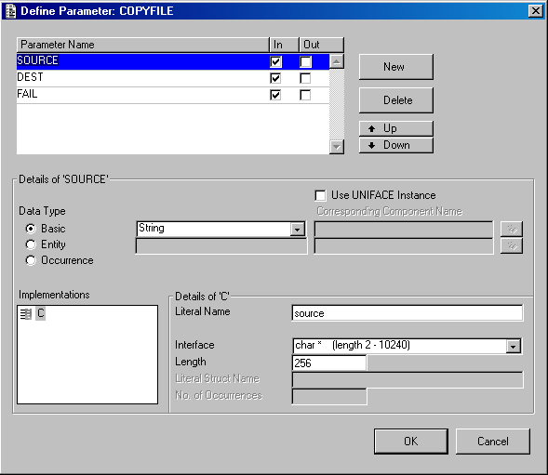

Define the parameters set up the parameters to match those of the DLL operation. The “Data Type” property refers to the Uniface Data type, the “Interface” property specifies how that data type is handled by the DLL operation.

In this case, the literal name is not important. The thing to watch is the length and the interface type. Especially length, getting length wrong in a call to a C interface can cause the dreaded “General Protection Failure” as the DLL attempts to write to memory it doesn’t own.

Compile the Signature.
Having created the required operations and parameters, compile the signature (File/Compile Signature) and it is available for use from within Uniface applications.

Uniface code

External signatures are implemented using the activate statement

Example
activate "win32".getusername(username,length) ;

Note: The operation name is as defined in the signature; it is NOT the specified literal name.

There are no other requirements. If all is done correctly, it will just work, despite the fact that you are using a function from Kernel32.DLL and you haven’t told the signature which DLL the operation is in.

Example Code for getting username

variables
string username
endvariables

activate "win32".GETUSERNAME(username, 90)

$$g_user_name = username
uppercase $$g_user_name,$$g_user_name
if ($$g_user_name = "")
message/error $text(M_91041)
return(-1)
endif

