PREFACE
This document describes the steps to take to install a UNIFACE Eight release, including web, on a Windows NT4 workstation.
Prerequisite:
- Intel Windows NT4
- Solid Server 2.3
- Microsoft IIS / PWS (from option pack 4, available on the Unilab network at
including:
- Management console. If installed, this is available through Start Menu:Programs:Windows NT 4.0 Option Pack:Microsoft Personal Web Server:Internet Service Manager.
- Windows Scripting Host. Whether this is installed can only be checked by rerunning the installation program.
- Java Virtual machine (newest from http://windowsupdate.microsoft.com/). This is used for the graphical editor (Neon).
- Set the environment variable: LM_LICENSE_FILE=path://unifcac1.dat

UNIFACE INSTALLATION
- Install UNIFACE 8.0.0
- Stop the running SOLID database
- Change the file idf.asn to include the following:
[settings]
$putmess_logfile=idf%p.log
$search_descriptor=dbms_first
$search_object=dbms_first
- Create a file userver.asn by copying file idf.asn and replace idf%p.log by userver%p.log.
- (If you have an existing error_en directory, copy it to <UNIFACE Install Dir>\urd\webapp\error_en)

WEB SPECIFICS
- Start the "Internet Service Manager" from option pack 4
- Expand tree "Internet Information Server"
- Right click on "Default Web Site" → Properties
- Go to tab "Directory Security"
- Edit the "Anonymous Access and Authentication Control"
- Change the settings to ONLY "Allow Anonymous Access". If you forget this you will get continuous logon forms, without any error messages anywhere (not in event viewer/logfiles).

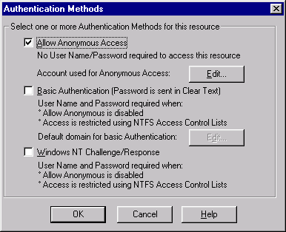
- Create a Virtual directory called webapp pointing to <UNIFACE Install Dir>\urd\webapp with "Read Access"
- Put your domain user (domain\username) into the "UNIFACE Server Users" in the NT4 User manager.
- Add the following rights to the UNIFACE Server Users:
* Act as a part of the operating System
* Replace a process level token
* Increase quotas
* Log on as a batch job

Install JRun
1) Stop the World Wide Web Publishing Service.
Open Services in you control panel and browse to the entry World Wide Web Publishing Service. If the service is started, stop it by selecting the service and click the Stop button.
Now, you can install JRun

You will get the dialog shown below:
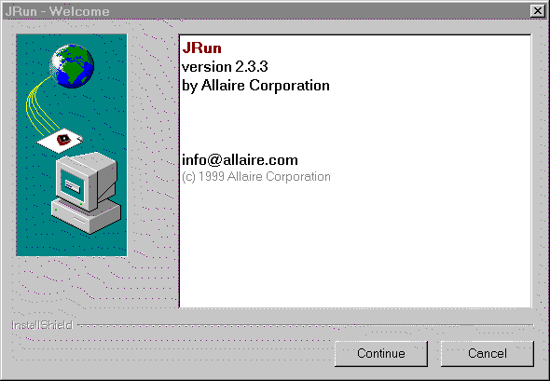
2) Click continue.
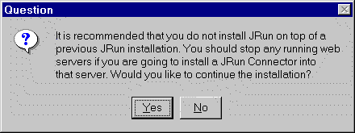
The web server has been already stopped in step 1.
3) Click Yes.
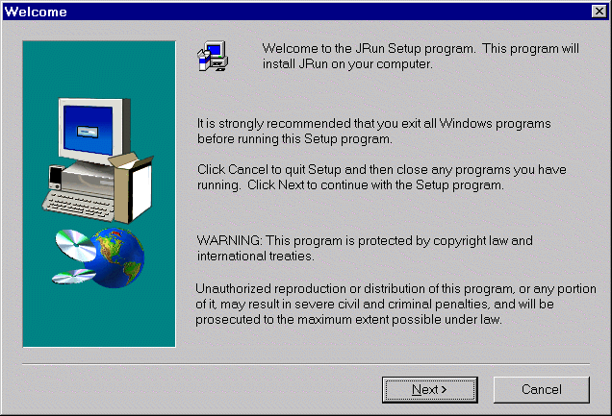
4) Click Next
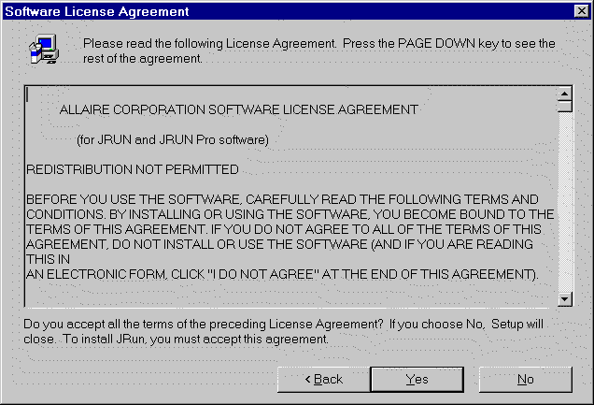
5) Click Yes
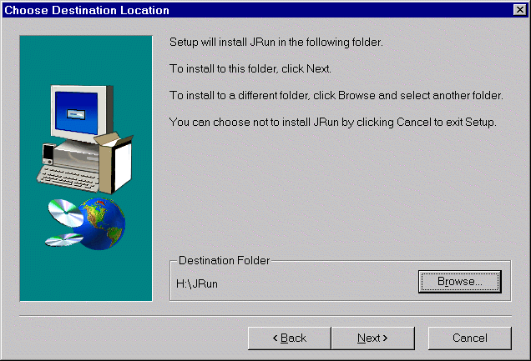
Here you select the installation loaction of JRun. JRun needs about 50MB of harddisk space.
6) Click Next after choosing the installation location
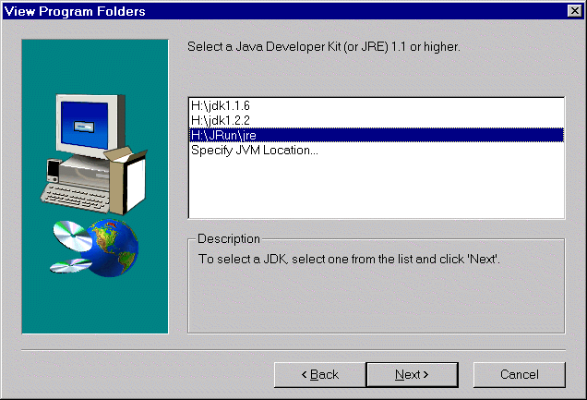
A Servlet Engine always uses a Java Virtual Machine. You can have multiple JVM installed on a sinlge machine. JRun has its own Java Virtual Machine, and this is the one to select. The location of the JRun JRE is in the JRun installation location.
7) Select the line with <JRun location>\jre and click Next.
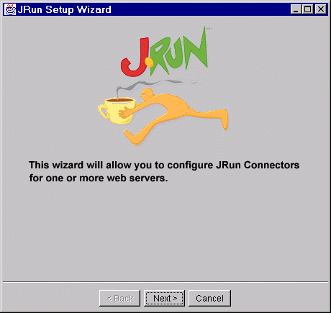
8) Click Next.
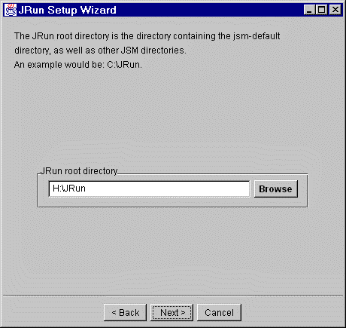
9) Click Next.
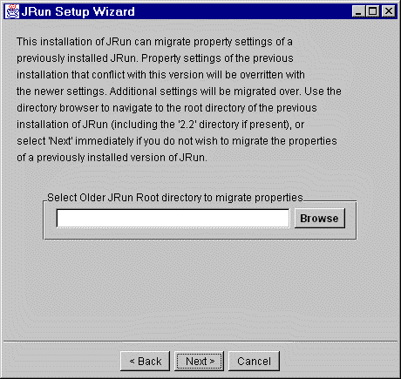
10) Click Next.
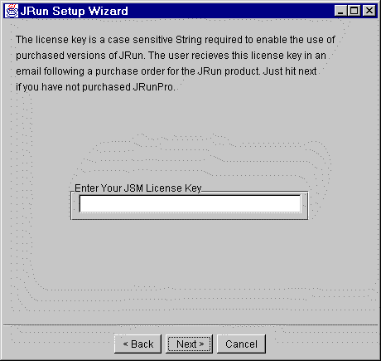
11) Click Next.
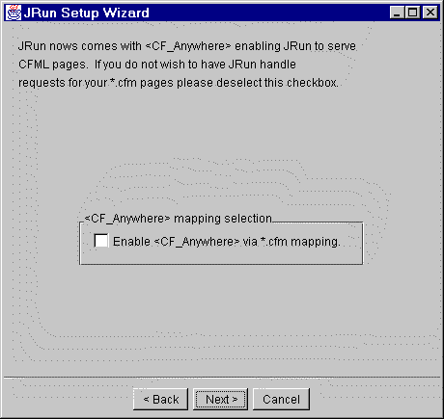
12) Click Next.
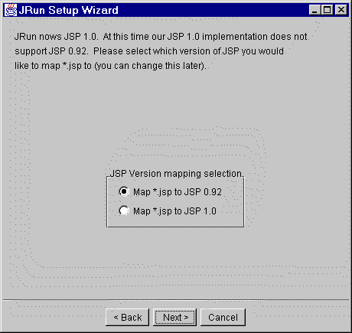
13) Click Next.
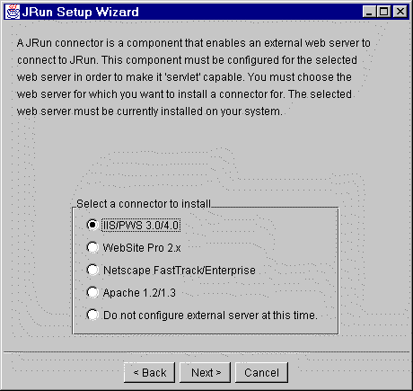
JRun needs to which web server it should use. Select the connector IIS/PWS 3.0/4.0. This is the connector for the Microsofts Internet Information Server.
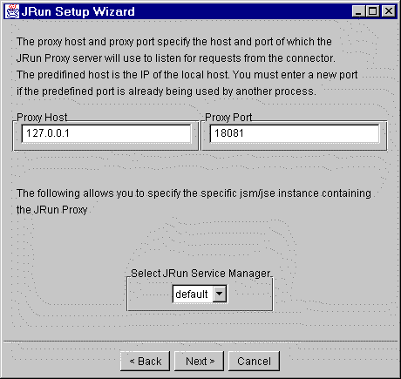
Here you configure the port number which the connector in IIS uses to talk to the JRun servlet engine. The default 8081 might already be in use when you have installed multiple web servers. If the default of 8081 is still available, use it.
14) Click Next.
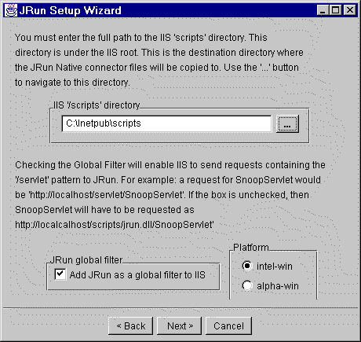
Here you select the location to put the jrun.dll. It should be placed in the scripts sub-directory of the IIS Inetpub directory. I you have chosen the default locations with the Option Pack installation, then it the location is C:\Inetpub\scripts
15) Browse to the scripts sub-directory of \Inetpub. Click Next.
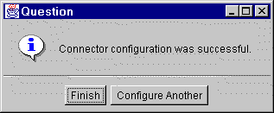
16) Click Finish.
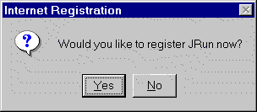
17) Click No.
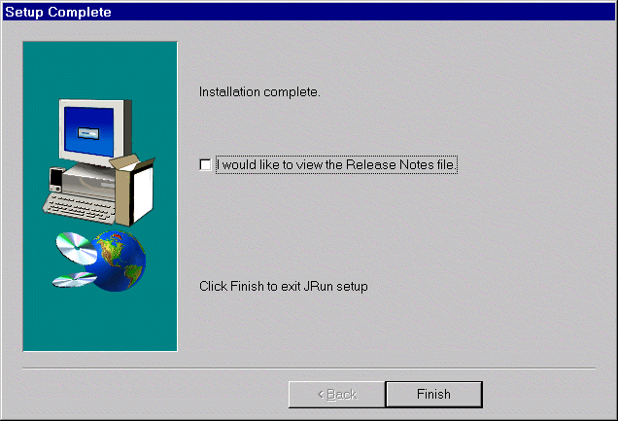
18) Click Finish
19) Restart your machine.
20) Right click the tray icon of your Personal Web Server, and choose from the popup menu Start Service.
21) Test the JRun installation
The JRun installation has created a new service: JRun Service Manager.
To be able to execute servlets, both the World Wide Web Publishing Service and the JRun Service Manager should be started. Make sure both services are started and point your brower to: http://localhost/HelloWorldServlet.jrun
A page with the words 'Hello World' is displayed:
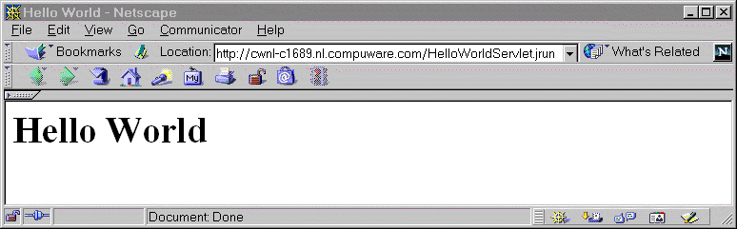

➔ DO NOT GO ON IF THIS DOES NOT WORK. ⬅

Configure the URD Servlet in JRun in 13 steps
Now the JRun has to be configured to use the URD Servlet to connect to a Uniface Application service.
The JRun installation has created a shortcut in the Start menu to the JRun administration tool:

Start -> Programs -> JRun -> JRun administrator
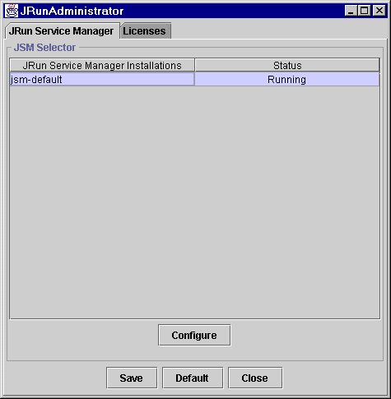
It is possible in JRun to use multiple groups each with its own deployment settings. This configuration example will use the default group 'jsm-default' created at installation time.
1) Select jsm-default and click Configure.
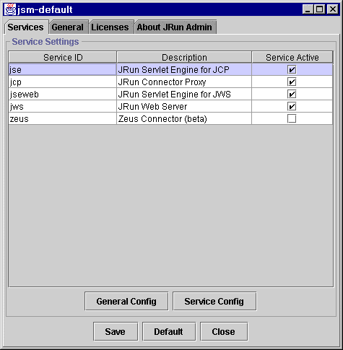
First JRun should know where to find the URD Servlet. This requires adding the urd2012.jar file to the JVMs's CLASSPATH.
2) Select the General Tab, and on this tab page, the Java Tab.
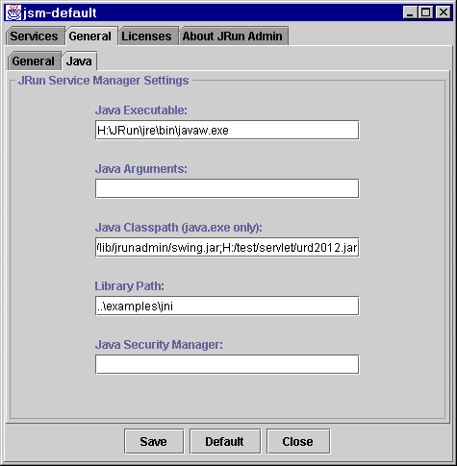
3) Extend the Java Classpath to include the <UNIFACE Install Dir>\urd\servlet\urd2012.jar file. Do not include any blanks in this line! Click Save. (You can start typing in an edit box by double clicking it.)
4) Go back to the Services Tab page
5) Select the jse Service and click Service Config.
6) Click the Aliases Tab
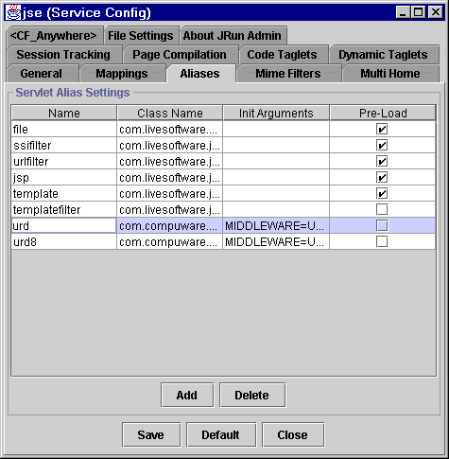
If you have 2 uniface web environments installed, you for example also have here an extra item:
<TBODY>urd8008 | ...</TBODY>
Here we can create an alias for the URD Servlet. Multiple aliases allows you to use the same Servlet, but with different settings. For instance, you can create aliases to connect the URD Servlet to different UNIFACE Application services.
7) Click Add and use urd as Name, com.compuware.uniface.urd.URDServlet as Class Name
The URD Servlet needs settings to be able to connect to the UNIFACE Application server and to redirect requests.
8) Double click the Init Arguments, a Init Args Editor will popup
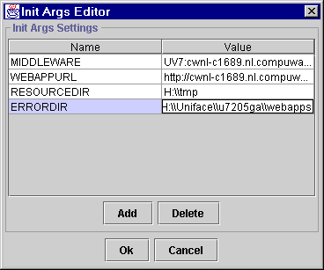
Create (Add) five settings:
<TBODY>MIDDLEWARE | If you use Uniface 8006:  UV8:TCP:localhost|<domain user*>|<password>| + SRU:|||  If you use Uniface 8008:  UV8:localhost|<domain user*>|<password>|myust
WEBAPPURL | http://your.fully.qualified.host.name/webapp
RESOURCEDIR | c:\\Temp
ERRORDIR | <Uniface Installation directory>\\webapp
AUTHORIZATION | My secure UNIFACE application</TBODY>
*) Example of a domain user: CWEU-USERS\cwnl-sbakker
In the ERRORDIR entry make sure you use double backslashes in the path name, since the backslash character is an escape character here.
Click OK, Click Save
Now you will need to configure a URI mapping to this newly created alias, so you can request the URD Servlet using a browser
9) Select the Mappings Tab.
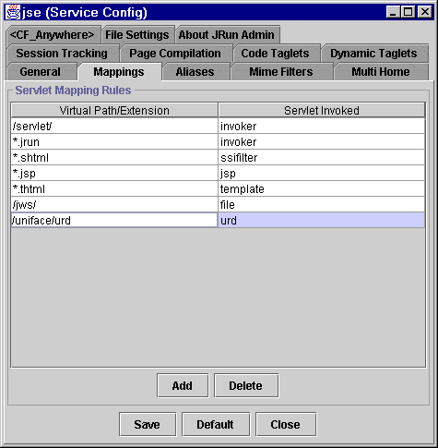
If you have 2 uniface web environments installed, you for example also have here an extra item:
<TBODY>/uniface/urd8008 | urd8008</TBODY>

The Servlet Invoked field specifies which servlet (or alias) will be invoked if the web server receives requests of which the URI starts with the Virtual Path.
10) Click Add and use /uniface/urd as Virtual Path and urd as Servlet Invoked, click Save
JRun does not immediately use this new configuration, it needs to be restarted.
11) Stop the World Wide Web Publishing and JRun administration service and then starts them both
Now you can request Uniface Server Pages with the following URL:
http://localhost/uniface/urd/run/MyUSP
12) Start Solid and the urouter process and give it a minute to start-up
13) Test the servlet by typing the following URL: http://localhost/uniface/urd/run/dummy
You now should get a UNIFACE -50 error in your browser. In case of problems check the file: <Disk>:\JRun\jsm-default\services\jse\logs\error.log

TROUBLE SHOOTING
- When you first installed the whole configuration, do a restart of the server first to make sure that you’re running a complete clean environment.
- If you get a 500 (internal IE error) in your browser all the time, and the error logfile in "<Disk>:\JRun\jsm-default\services\jse\logs\error.log" remains empty, you might have written a "blank" in the classpath line of the servlet definition. (There where you should enter urd2012.jar --> point 2 of servlet configuration).
- When you get a UNIFACE/URD error, check the most recent logfiles in the <UNIFACE Install Dir>\Project directory. If this does not give a clear cause, you can shut down the urouter. Then start the urouter and try again.
- When images are not shown, try to access them directly through http://your.qualified.hostname/webapp/images/imagename.gif If this works, there is probably something wrong with the servlet or one of its parameters (WEBAPPURL)
- When you change a Servlet setting, you should restart the Jrun engine.
- When it doesn't work, you can investigate this by adding $ioprint=511 to userver.asn, and then examine the userver*.log file that it creates in directory c:\winnt\system32 (or the like).
- Each time when you do a new experiment, stop and restart urouter first.
- Make sure that in userver.asn you use the correct solid, username and password etc.

